***Name: Amish Sabir***

***Reg No: FA19_BCS_090***

**welcome.dart**

*import* 'package:flutter/cupertino.dart';  
*import* 'package:flutter/material.dart';  
*import* 'package:xylophone_app/main.dart';  
*import* 'package:xylophone_app/settings.dart';  
*void* main() => runApp(welcome());  
*class* welcome *extends* StatelessWidget {  
  
  
 @override  
 Widget build(BuildContext context) {  
 *return* MaterialApp(  
 debugShowCheckedModeBanner: *false*,  
 home: Scaffold(  
  
 body: welcomepage(),  
 ),  
 );  
 }  
}  
*class* welcomepage *extends* StatefulWidget {  
  
 @override  
 _welcomepageState createState() => _welcomepageState();  
}  
  
*class* _welcomepageState *extends* State<welcomepage> {  
 String _selectedLocation1='green',_selectedLocation2='1',_selectedLocation3,_selectedLocation4='2',_selectedLocation5,_selectedLocation6='3'  
 ,_selectedLocation7,_selectedLocation8='4',_selectedLocation9,_selectedLocation10='5',_selectedLocation11,_selectedLocation12='6'  
 ,_selectedLocation13,_selectedLocation14='7';  
 @override  
 Widget build(BuildContext context) {  
 *return* Container(  
 decoration: BoxDecoration(  
 image: DecorationImage(  
 image: AssetImage("images/child.webp"),  
 fit: BoxFit.cover,  
 ),  
 ),  
 child: Column(  
 mainAxisAlignment: MainAxisAlignment.start,  
 children: [  
 SizedBox(height: 100,),  
 Row(  
  
 mainAxisAlignment: MainAxisAlignment.center,  
 children: [  
 Container(  
 height: 200,  
 width: 200,  
 decoration: BoxDecoration(  
 image: DecorationImage(  
 image: AssetImage('images/bear.gif'),  
  
 ),  
 ),  
  
  
 ),  
  
 ],  
 ),  
 SizedBox(height: 50,),  
  
 Column(  
 children: [  
 Row(  
 mainAxisAlignment: MainAxisAlignment.center,  
 children: [  
 Container(  
 child: TextButton(  
 child: Image.asset("images/play.png"),  
 onPressed: () {  
 Navigator.*push*(  
 context,  
 MaterialPageRoute(builder: (context) => XylophoneApp(selectedLocation1:0xFF42A5F5,selectedLocation3:0xFFFFA500,selectedLocation5:0xFFFFFF00,selectedLocation7:0xFF00FF00,selectedLocation9:0xFF008080,selectedLocation11:0xFF0000FF,selectedLocation13:0xFF6a0dad,selectedLocation2:int.*parse*(_selectedLocation2),selectedLocation4:int.*parse*(_selectedLocation4),selectedLocation6:int.*parse*(_selectedLocation6),selectedLocation8:int.*parse*(_selectedLocation8),selectedLocation10:int.*parse*(_selectedLocation10),selectedLocation12:int.*parse*(_selectedLocation12),selectedLocation14:int.*parse*(_selectedLocation14))),  
 );  
 },  
 )  
  
  
 ),  
  
 ],  
  
 ),  
  
  
  
 Row(  
  
 mainAxisAlignment: MainAxisAlignment.center,  
 children: [  
 Container(  
 child: TextButton(  
 child: Image.asset("images/setting.png"),  
 onPressed: () {  
 Navigator.*push*(  
 context,  
 MaterialPageRoute(builder: (context) => settings()),  
  
 );  
 },  
 )  
 ),  
 ],  
 ),  
  
 ],  
 ),  
 ],  
 ),  
 );  
 }  
}

**main.dart**

*import* 'package:flutter/material.dart';  
*import* 'package:audioplayers/audioplayers.dart';  
*import* 'package:splashscreen/splashscreen.dart';  
*import* 'package:xylophone_app/welcome.dart';  
*import* 'package:xylophone_app/settings.dart';  
*void* main() => runApp(welcome());  
  
  
*class* MyApp *extends* StatefulWidget {  
 @override  
 _MyAppState createState() => *new* _MyAppState();  
}  
  
*class* _MyAppState *extends* State<MyApp> {  
 @override  
  
 Widget build(BuildContext context) {  
  
 *return* SplashScreen(  
  
 seconds: 40,  
 navigateAfterSeconds: XylophoneApp(),  
 title: Text(  
 'Welcome In SplashScreen',  
 style: TextStyle(fontWeight: FontWeight.*bold*, fontSize: 20.0),  
 ),  
 image: Image.network(  
 'https://flutter.io/images/catalog-widget-placeholder.png'),  
 backgroundColor: Colors.*white*,  
 loaderColor: Colors.*red*,  
 );  
 }  
}  
  
*class* XylophoneApp *extends* StatelessWidget {  
 *var* selectedLocation3,selectedLocation5,selectedLocation7,selectedLocation9,selectedLocation11,selectedLocation13,selectedLocation2,selectedLocation4,selectedLocation6,selectedLocation8,selectedLocation10,selectedLocation12,selectedLocation14,selectedLocation1;  
 XylophoneApp({*this*.selectedLocation1,*this*.selectedLocation3,*this*.selectedLocation5,*this*.selectedLocation7,*this*.selectedLocation9,*this*.selectedLocation11,*this*.selectedLocation13,*this*.selectedLocation2,*this*.selectedLocation4, *this*.selectedLocation6, *this*.selectedLocation8, *this*.selectedLocation10, *this*.selectedLocation12, *this*.selectedLocation14});  
  
 *void* playSound(int soundNumber) {  
 *final* player = AudioCache();  
 player.play('note$soundNumber.wav');  
 }  
  
 Expanded buildKey({Color color, int soundNumber}) {  
 *return* Expanded(  
 child: FlatButton(  
 color: color,  
 onPressed: () {  
 playSound(soundNumber);  
 },  
 ),  
 );  
 }  
 String colors(String value ){  
  
 *if*( value =='sky' )  
 {  
  
 selectedLocation1=0xFF42A5F5;  
 *return* selectedLocation1;  
 }  
  
 }  
  
 @override  
 Widget build(BuildContext context) {  
 *return* MaterialApp(  
 debugShowCheckedModeBanner: *false*,  
 home: Scaffold(  
 backgroundColor: Colors.*black*,  
 body: SafeArea(  
 child: Column(  
  
 crossAxisAlignment: CrossAxisAlignment.stretch,  
 children: <Widget>[  
 buildKey(color: Color(selectedLocation1), soundNumber: selectedLocation2),  
 buildKey(color: Color(selectedLocation3), soundNumber: selectedLocation4),  
 buildKey(color: Color(selectedLocation5), soundNumber: selectedLocation6),  
 buildKey(color: Color(selectedLocation7), soundNumber: selectedLocation8),  
 buildKey(color: Color(selectedLocation9), soundNumber: selectedLocation10),  
 buildKey(color: Color(selectedLocation11), soundNumber: selectedLocation12),  
 buildKey(color: Color(selectedLocation13), soundNumber: selectedLocation14),  
 ],  
 ),  
 ),  
 ),  
 );  
 }  
}

**settings.dart**

*import* 'package:flutter/material.dart';  
*import* 'package:xylophone_app/main.dart';  
*import* 'package:string_to_hex/string_to_hex.dart';  
*class* settings *extends* StatelessWidget {  
  
 @override  
 Widget build(BuildContext context) {  
 *return* MaterialApp(  
 debugShowCheckedModeBanner: *false*,  
 home: Scaffold(  
 backgroundColor: Colors.*lightBlueAccent*,  
 appBar: AppBar(  
 title: Text("Settings"),  
 leading: Icon(  
 Icons.*app_settings_alt_rounded*,  
 ),  
 backgroundColor: Colors.*lightGreen*,  
 ),  
  
 body:  
 setting(),  
  
  
 ),  
 );  
 }  
}  
  
*class* setting *extends* StatefulWidget {  
  
  
 @override  
 _settingState createState() => _settingState();  
}  
  
*class* _settingState *extends* State<setting> {  
 List<String> _Colors = ['sky', 'orange', 'yellow', 'green','teal','blue','purple'];  
 List<String> _Colors1 = ['sky', 'orange', 'yellow', 'green','teal','blue','purple'];  
 List<String> _Colors2 = ['sky', 'orange', 'yellow', 'green','teal','blue','purple'];  
 List<String> _Colors3 = ['sky', 'orange', 'yellow', 'green','teal','blue','purple'];  
 List<String> _Colors4 = ['sky', 'orange', 'yellow', 'green','teal','blue','purple'];  
 List<String> _Colors5 = ['sky', 'orange', 'yellow', 'green','teal','blue','purple'];  
 List<String> _Colors6 = ['sky', 'orange', 'yellow', 'green','teal','blue','purple'];  
 List<String> _Colors7 = ['sky', 'orange', 'yellow', 'green','teal','blue','purple'];  
 List<String> _Notes = ['1', '2', '3', '4','5','6','7'];  
 List<String> _Notes1 = ['1', '2', '3', '4','5','6','7'];  
 List<String> _Notes2 = ['1', '2', '3', '4','5','6','7'];  
 List<String> _Notes3 = ['1', '2', '3', '4','5','6','7'];  
 List<String> _Notes4 = ['1', '2', '3', '4','5','6','7'];  
 List<String> _Notes5 = ['1', '2', '3', '4','5','6','7'];  
 List<String> _Notes6 = ['1', '2', '3', '4','5','6','7'];  
 List<String> _Notes7 = ['1', '2', '3', '4','5','6','7'];  
  
 String _selectedLocation1='sky',_selectedLocation2='1',_selectedLocation3='orange',_selectedLocation4='2',_selectedLocation5='yellow',_selectedLocation6='3'  
 ,_selectedLocation7='green',_selectedLocation8='4',_selectedLocation9='teal',_selectedLocation10='5',_selectedLocation11='blue',_selectedLocation12='6'  
 ,_selectedLocation13='purple',_selectedLocation14='7';  
  
 @override  
 Widget build(BuildContext context) {  
 *return* Container(  
 decoration: *const* BoxDecoration(  
 gradient: LinearGradient(  
 begin: Alignment.*topRight*,  
 end: Alignment.*bottomLeft*,  
 colors: [  
 Colors.*green*,  
 Colors.*amber*,  
 ],  
 )  
 ),  
 child: Column(  
 crossAxisAlignment: CrossAxisAlignment.center,  
 children: [  
 Row(  
  
 children: [  
 Expanded(child: Text('Colors'),),  
 Expanded(child: Text('Notes'),),  
 ],  
 ),  
 SizedBox(  
 height: 30,  
 ),  
 Row(  
 children: [  
 Expanded(child: DropdownButton(  
 hint: Text('Colors'), *// Not necessary for Option 1* value: _selectedLocation1,  
 onChanged: (newValue) {  
 setState(() {  
 _selectedLocation1 = newValue;  
 });  
 },  
 items: _Colors1.map((location) {  
 *return* DropdownMenuItem(  
 child: *new* Text(location),  
 value: location,  
 );  
 }).toList(),  
 ),),  
 Expanded(child: DropdownButton(  
 hint: Text('Notes'), *// Not necessary for Option 1* value: _selectedLocation2,  
 onChanged: (newValue) {  
 setState(() {  
 _selectedLocation2 = newValue;  
 });  
 },  
 items: _Notes1.map((location) {  
 *return* DropdownMenuItem(  
 child: *new* Text(location),  
 value: location,  
 );  
 }).toList(),  
 ),),  
 ],  
 ),  
 Row(  
 children: [  
 Expanded(child: DropdownButton(  
 hint: Text('Colors'), *// Not necessary for Option 1* value: _selectedLocation3,  
 onChanged: (newValue) {  
 setState(() {  
 _selectedLocation3 = newValue;  
 });  
 },  
 items: _Colors2.map((location) {  
 *return* DropdownMenuItem(  
 child: *new* Text(location),  
 value: location,  
 );  
 }).toList(),  
 ),),  
 Expanded(child: DropdownButton(  
 hint: Text('Notes'), *// Not necessary for Option 1* value: _selectedLocation4,  
 onChanged: (newValue) {  
 setState(() {  
 _selectedLocation4 = newValue;  
 });  
 },  
 items: _Notes2.map((location) {  
 *return* DropdownMenuItem(  
 child: *new* Text(location),  
 value: location,  
 );  
 }).toList(),  
 ),),  
 ],  
 ),  
 Row(  
 children: [  
 Expanded(child: DropdownButton(  
 hint: Text('Colors'), *// Not necessary for Option 1* value: _selectedLocation5,  
 onChanged: (newValue) {  
 setState(() {  
 _selectedLocation5 = newValue;  
 });  
 },  
 items: _Colors3.map((location) {  
 *return* DropdownMenuItem(  
 child: *new* Text(location),  
 value: location,  
 );  
 }).toList(),  
 ),),  
 Expanded(child: DropdownButton(  
 hint: Text('Notes'), *// Not necessary for Option 1* value: _selectedLocation6,  
 onChanged: (newValue) {  
 setState(() {  
 _selectedLocation6 = newValue;  
 });  
 },  
 items: _Notes3.map((location) {  
 *return* DropdownMenuItem(  
 child: *new* Text(location),  
 value: location,  
 );  
 }).toList(),  
 ),),  
 ],  
 ),  
 Row(  
 children: [  
 Expanded(child: DropdownButton(  
 hint: Text('Colors'), *// Not necessary for Option 1* value: _selectedLocation7,  
 onChanged: (newValue) {  
 setState(() {  
 _selectedLocation7 = newValue;  
 });  
 },  
 items: _Colors4.map((location) {  
 *return* DropdownMenuItem(  
 child: *new* Text(location),  
 value: location,  
 );  
 }).toList(),  
 ),),  
 Expanded(child: DropdownButton(  
 hint: Text('Notes'), *// Not necessary for Option 1* value: _selectedLocation8,  
 onChanged: (newValue) {  
 setState(() {  
 _selectedLocation8 = newValue;  
 });  
 },  
 items: _Notes4.map((location) {  
 *return* DropdownMenuItem(  
 child: *new* Text(location),  
 value: location,  
 );  
 }).toList(),  
 ),),  
 ],  
 ),  
 Row(  
 children: [  
 Expanded(child: DropdownButton(  
 hint: Text('Colors'), *// Not necessary for Option 1* value: _selectedLocation9,  
 onChanged: (newValue) {  
 setState(() {  
 _selectedLocation9 = newValue;  
 });  
 },  
 items: _Colors5.map((location) {  
 *return* DropdownMenuItem(  
 child: *new* Text(location),  
 value: location,  
 );  
 }).toList(),  
 ),),  
 Expanded(child: DropdownButton(  
 hint: Text('Notes'), *// Not necessary for Option 1* value: _selectedLocation10,  
 onChanged: (newValue) {  
 setState(() {  
 _selectedLocation10 = newValue;  
 });  
 },  
 items: _Notes5.map((location) {  
 *return* DropdownMenuItem(  
 child: *new* Text(location),  
 value: location,  
 );  
 }).toList(),  
 ),),  
 ],  
 ),  
 Row(  
 children: [  
 Expanded(child: DropdownButton(  
 hint: Text('Colors'), *// Not necessary for Option 1* value: _selectedLocation11,  
 onChanged: (newValue) {  
 setState(() {  
 _selectedLocation11 = newValue;  
 });  
 },  
 items: _Colors6.map((location) {  
 *return* DropdownMenuItem(  
 child: *new* Text(location),  
 value: location,  
 );  
 }).toList(),  
 ),),  
 Expanded(child: DropdownButton(  
 hint: Text('Notes'), *// Not necessary for Option 1* value: _selectedLocation12,  
 onChanged: (newValue) {  
 setState(() {  
 _selectedLocation12 = newValue;  
 });  
 },  
 items: _Notes6.map((location) {  
 *return* DropdownMenuItem(  
 child: *new* Text(location),  
 value: location,  
 );  
 }).toList(),  
 ),),  
 ],  
 ),  
 Row(  
 children: [  
 Expanded(child: DropdownButton(  
 hint: Text('Colors'), *// Not necessary for Option 1* value: _selectedLocation13,  
 onChanged: (newValue) {  
 setState(() {  
 _selectedLocation13 = newValue;  
 });  
 },  
 items: _Colors7.map((location) {  
 *return* DropdownMenuItem(  
 child: *new* Text(location),  
 value: location,  
 );  
 }).toList(),  
 ),),  
 Expanded(child: DropdownButton(  
 hint: Text('Notes'), *// Not necessary for Option 1* value: _selectedLocation14,  
 onChanged: (newValue) {  
 setState(() {  
 _selectedLocation14 = newValue;  
 });  
 },  
 items: _Notes7.map((location) {  
 *return* DropdownMenuItem(  
 child: *new* Text(location),  
 value: location,  
 );  
 }).toList(),  
 ),),  
 ],  
 ),  
  
Row(  
 mainAxisAlignment: MainAxisAlignment.center,  
 children: [  
  
 Container(  
 height: 100,  
 width: 100,  
 child: TextButton(  
  
 child: Image.asset("images/play2.png"),  
 onPressed: () {  
 Navigator.*push*(  
 context,  
  
 MaterialPageRoute(builder: (context) => XylophoneApp(selectedLocation1:StringToHex.*toColor*(_selectedLocation1),selectedLocation3:StringToHex.*toColor*(_selectedLocation3),selectedLocation5:StringToHex.*toColor*(_selectedLocation5),selectedLocation7:StringToHex.*toColor*(_selectedLocation7),selectedLocation9:StringToHex.*toColor*(_selectedLocation9),selectedLocation11:StringToHex.*toColor*(_selectedLocation11),selectedLocation13:StringToHex.*toColor*(_selectedLocation13),selectedLocation2:int.*parse*(_selectedLocation2),selectedLocation4:int.*parse*(_selectedLocation4),selectedLocation6:int.*parse*(_selectedLocation6),selectedLocation8:int.*parse*(_selectedLocation8),selectedLocation10:int.*parse*(_selectedLocation10),selectedLocation12:int.*parse*(_selectedLocation12),selectedLocation14:int.*parse*(_selectedLocation14))));  
 },  
 )  
 ),  
 ],  
),  
  
 ],  
 ),  
 );  
 }  
}

**Screenshots**

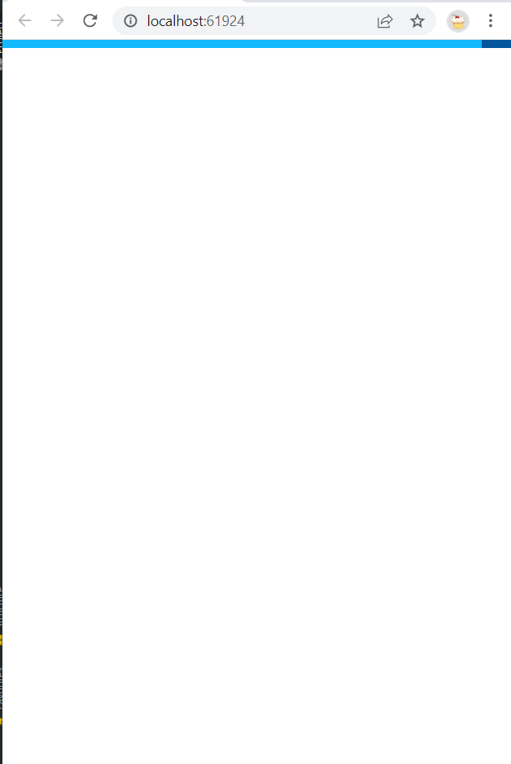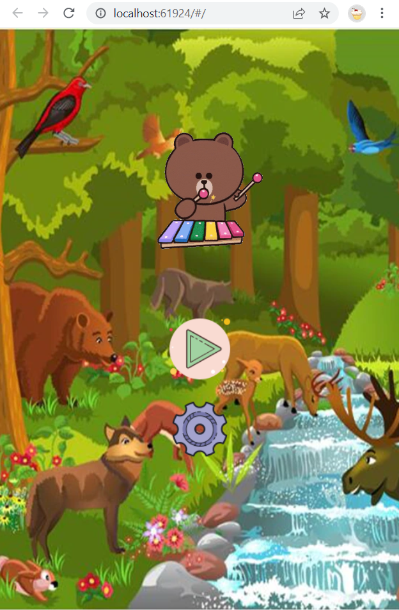

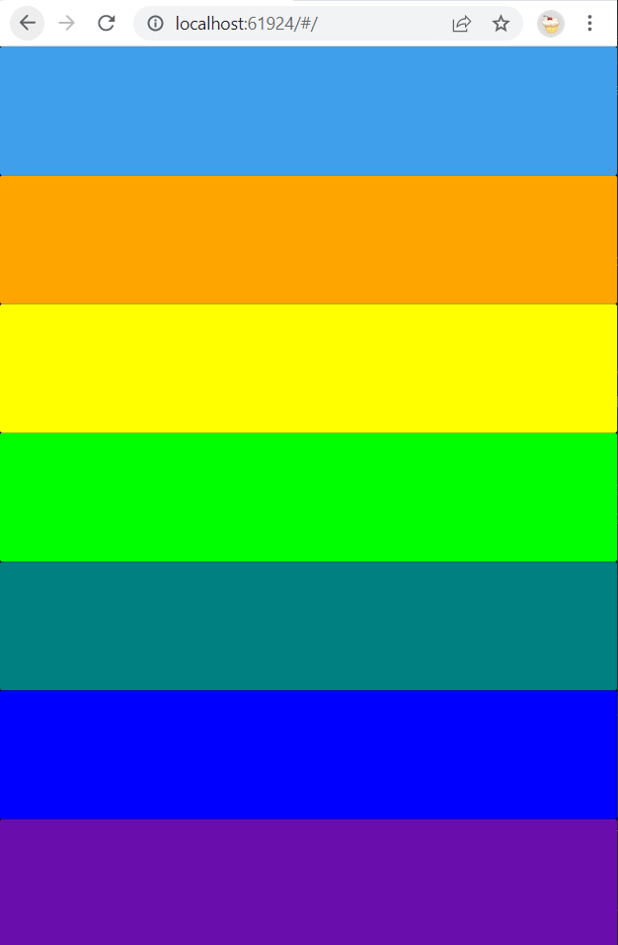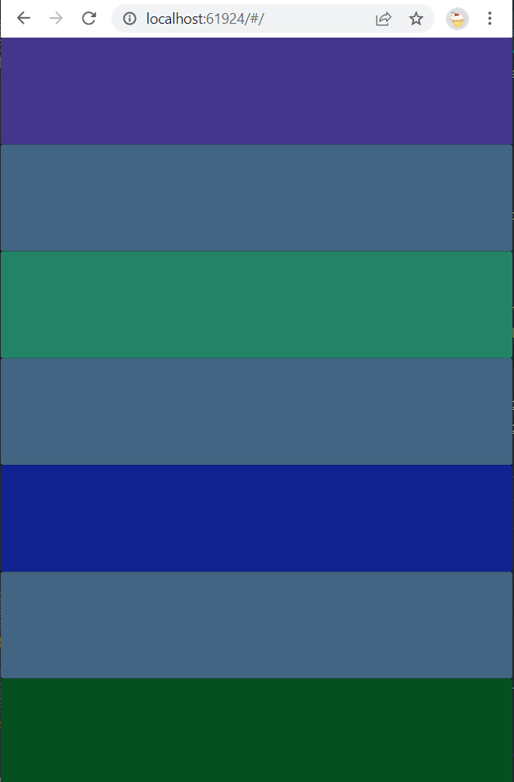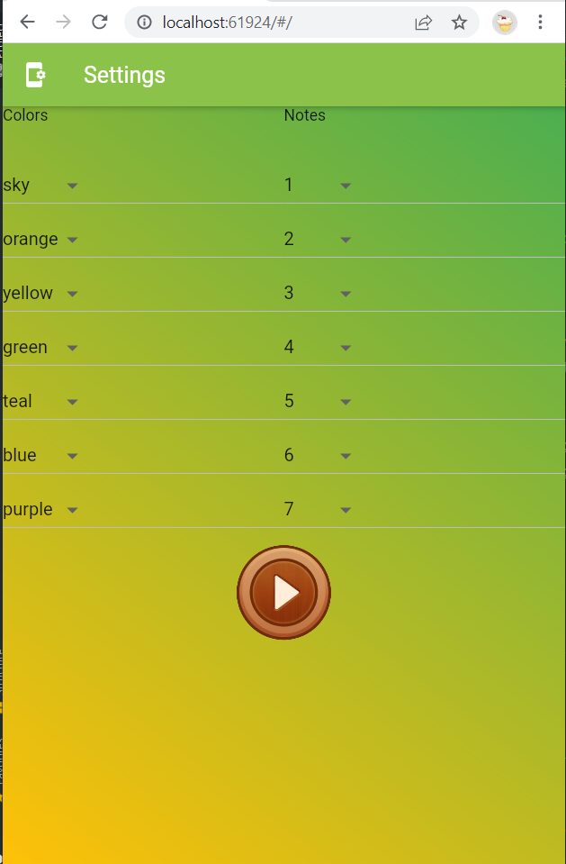

**AVD ScreenShots**

